1. 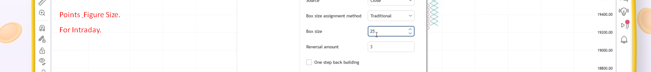
2. If top breakout, then upside, if down breakout, then downside trend.